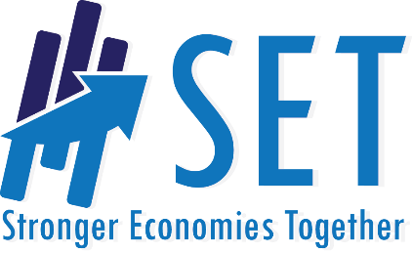
Are We Ready?

Read each question below and place an X to show the answer that best reflects your response. There are no right or wrong responses. These are simply discussion starters for your group.

Regional Knowledge & Efforts | Not at all | Only a Little | Some | A Lot
- How much has the region worked together in the past?

- How successful have efforts to work together in the past been?

- How much of a concern is regional economic development in your region?
- How knowledgeable do you think the SET partners are in practices around regional economic development
Leadership
- To what extent are local elected/appointed officials knowledgeable of regional economic development benefits
- To what extent are local elected/appointed officials consider regional economic development efforts to be an important use of resources (time and money)
- To what extent are local elected/appointed officials already involved in regional economic development efforts
Community Climate
- How supportive do you think community members are to efforts toward regional economic development
Knowledge
- How knowledgeable are community members about regional economic development?
- How much regional data have the applicants examined (such as demographics, workforce, industry clusters, or other relevant data)?
Resources
- How broad is the representation of participants that will be involved in planning (such as education, industry, healthcare, volunteer orgs, economic development, local citizens, etc.)?
- How much expertise and training is there among those to be included in this process?
- How supportive is the region in terms of volunteering time, making financial donations, providing meeting space, etc. in support of this work?
- How willing are major employers, industries, and organizations to be involved?
Count
Number | 1 | 2 | 3 | 4
Column Total

_____________Overall Total

