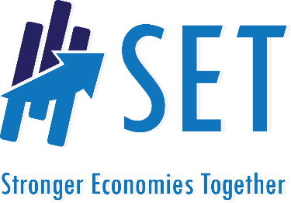
State Resource Team
Readiness Assessment Summary

Region: Date of Visit:

Visitor(s)

Check Point #1: Meeting of Key Partners - Can the region get the partners in the room?
- How many people came?

- How many different organizations were represented?

- Were there any obvious missing partners? (i.e. local government, education, business/industry, economic development) If so, who was missing?

Check Point #2: Coaches describe SET and outline expectations – Will the region commit to the roles?
  - Were all roles assigned?

  - How many people volunteered?

Check Point #3: Coaches distribute “Are We Ready” assessment followed by debrief with interview guide - How do the regional participants view their readiness?
  - What was the range of scores?

  - What was the average score?

  - What key strengths were discussed?

  - What key concerns were raised?

Check Point #4: Coaches go on tour with members of the regional team - Do coaches hear any concerns that might block the process or strengths that may aid in success?

  - What concerns were raised or observed?

  - What strengths or opportunities were shared or observed?

