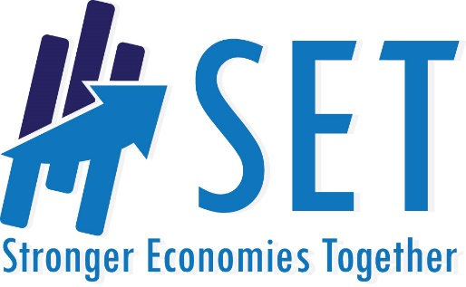

[Place Region Name Here]

[PLACE REGIONAL PHOTO HERE]

[date]

Contents

Stronger Economies Together Initiative

Executive Summary

Regional Description

Introduction

Acknowledgements

Regional Collaboration

Regional Economic Goals

Regional Economic Development Plan

[Goal 1]

[Goal 2]

[Goal 3]

[Goal 4]

Evidence Base for Plan

Regional Demographic Data

Regional Economic Data

Regional Assets

Potential Barriers

Appendix

Stronger Economies Together Initiative

Launched in 2009 by USDA Rural Development in collaboration with the nation’s Regional Rural Development Centers (RRDC) and their land-grant university partners. The purpose of Stronger Economies Together (SET) is to strengthen the capacity of communities in rural America to work together in developing and implementing an economic development blueprint that strategically builds on the current and emerging economic strengths of their region. Important elements of the Stronger Economies Together program will build collaboration between communities in a region, provides economic analyses that is tailored to help capture the region’s current or emerging clusters and comparative economic advantages and is supported by technical assistance provided by land-grant university extension systems to the regions over a period of several months including the SET training.

Additional text . . .

Why did your region apply?

When were you accepted as a SET region?

Provide an overview of the sessions and the impact the discussions have had.

Remember, keep this section to just a few paragraphs.

[REGION]

Executive Summary

Summarize what the reader will discover as they read this plan. For example, you might start the summary by expanding the following text . . .

This Regional Economic Development Plan will serve as the roadmap for the future economic development efforts of [PLACE REGION NAME HERE]. Key regional stakeholders embrace a spirit of regionalism to support this initiative. Implementing the action items described within this document will strengthen the ability of the [PLACE REGION NAME HERE] to secure its economic future and position it as a competitive region. This plan reflects a nine module planning process with active participation from business, civic, and community leaders. Significant research and discussions have led to the development of this plan.

[Region Name] Description

Insert a brief description of the region, including geographical span, history of working together, why this geography is a logical economic region.

[PLACE MAP OF REGION HERE]

Introduction

Acknowledgements

The [Region Name] Region would like to thank the staff from the United States Department of Agriculture Rural Development, Regional Rural Development Centers, and [Land Grant University] Extension for support throughout the course of this project. We would also like to show our appreciation to [List local sponsors and/or organizations here], the distinguished individuals that took part in the training sessions, and numerous other individuals, for their invaluable insight and ideas that led to the creation of this plan.

Regional Collaboration
[PLACE PHOTO HERE
[TRAINING SESSION / GROUP]

The plan has buy-in from several key decision makers in the region including [LIST ORGANIZATIONS/INDIVIDUALS].
Key decision makers’ explicitly expressed commitment to support the plan’s implementation by [INSERT EVIDENCE FOR SUPPORT, I.E. PROCLAMATION, LETTER, PARTICIPATION]

Additionally, public input and support was garnered through [describe how the plan was vetted with the larger region.]

Evidence Basis for Plan

Regional Demographic Data
Insert demographic data that supports or shows evidence of need for the plan.

Regional Economic Data
Add workforce or cluster that supports or shows evidence for the need the plan.

Regional Assets
Add information on the assets available in the region committed to help support the plan.

Potential Barriers and Related Strategies
Describe any significant barriers that the region will need to overcome and strategies. that will be implemented to overcome these

Regional Economic Goals

Based on this input from the region coupled with the resources explored throughout the Stronger Economies Together process, we recommend the following goals for the [Region Name] Region:

Goal One in SMART format

Goal Two in SMART format

Goal Three in SMART format

….

Regional Economic Development Plan

Goal 1: INSERT GOAL 1 – IN SMART FORMAT

Regional Economic Benefits
Describe how this goal will benefit the regional economy

Evidence Base for Goal

Describe the evidence to support the need for this goal

Strategies:

List key strategies designed to reach the goal

Target Outcomes:

Short Term:

Intermediate:

Long Term:

REPEAT THE GOAL SECTION ABOVE FOR EACH GOAL YOUR REGION HAS IDENTIFIED

Evaluation Plan

Key Measures and Strategies to Track Progress:
Measurement Plan

Appendix

Add Planning Group Members and affiliations
Add Training Team Members– USDA-RD and LGU Extension
Regional Economic Development Planning Chart)
Plan of Action
Measurement Plan(s)
Other relevant information or reference documents

Region’s Contact Information

Leadership name, contact

Website

Phone number

Email

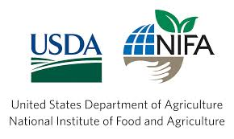
National Partnership for Stronger Economies Together

