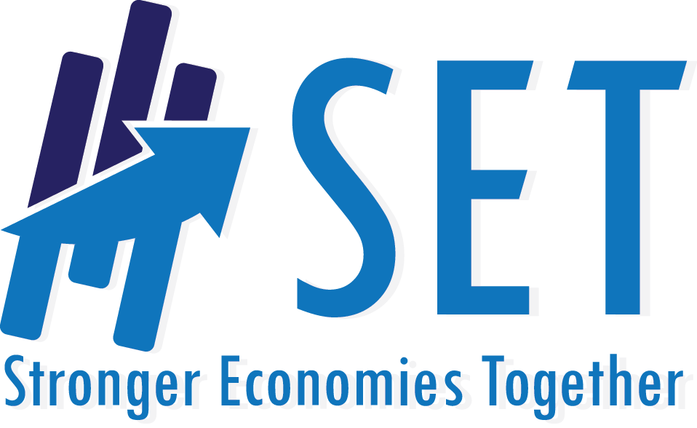
Stronger Economies Together
Training Session Summary Report
Please submit within one week of each session.

Regional Team: Training Date:

Training Location: Trainer(s):

Attendance Summary:
Number in attendance: ________
Number of new participants (first time attendees):________
Number of people representing each sector:

____ Government/elected officials
____ Education
____ Business/Industry
____ Economic Development
____ Non-profit
____ Healthcare
____ Faith-based
____ Other (please specify) ______________________

What Module(s) or other material did you cover in this session?

What has the regional team accomplished since the last session (including anything completed during this session)?

What suggestions do you have regarding the training material used in this session? What went well? What needs improvement?

What new insights do you, the trainer, have following this session?

What challenges has the regional team experienced since the last session? What has been done to address the challenges?

Has the region leveraged any additional funding because of their work together on SET? If yes, please explain (source, amount, purpose)

What are the plans for the next session? (Dates, material to cover, homework to consider, etc.)

