STEP FIVE

Prepare, Review, and Approve the Plan

By Bo Beaulieu

Purdue Center for Regional Development

Purdue University

Lori Garkovich

Community and Leadership Development

University of Kentucky

Rachel Welborn

Southern Rural Development Center

Mississippi State University

This facilitator’s guide outlines the content, activities, and handouts that should be used to teach this section. Refer to this document for detailed guidance on how to deliver ReadyCommunity Step Five.

STEP FIVE

Prepare, Review, and Approve the Plan

Before Starting Step Five…
Prior to moving on to Step Five the core and planning teams should complete these activities from Step Four:
- Complete the Emergency Plan Worksheets (Step Four - Handout 3)
- Host the Open House (refer to Step Four – Handout 4)
- Review the feedback obtained from the Open House and make adjustments to the plan

Step Five Overview
The purpose of Step Five is to move the planning process itself into its final form for approval. This will involve completing the writing of the preparedness plan; evaluating it for conformity to regulatory requirements of federal and state agencies, as well as its feasibility; and then, submitting it to the appropriate elected officials for approval. Finally, the plan should be disseminated throughout the community with specific efforts made to ensure that all persons and organizations, regardless of location in the community, have access to critical information from the plan.

Objectives
In Step Five, participants will:
- Complete the written plan
- Evaluate the plan for conformity to county/state guidelines.
- Conduct a scenario review of the plan
- Refine the plan based on scenario review
- Submit the plan to appropriate elected officials for approval
- Disseminate the plan to the public, especially vulnerable populations in the community.

Estimated Time to Complete Step Five Activities
Two Hours and 50 minutes plus additional time to complete the worksheets and activities in preparation for Step Six.

References to CPG 101
Pages 4-16 – 4-25

Prepare, Review, and Approve the Plan

In Step Five your local planning team will learn some simple rules for writing plans and procedures. They will review common criteria used to help decision makers determine the effectiveness and efficiency of the plan. The team will learn the importance of reviewing the plan to ensure it conforms to regulatory requirements. They will evaluate their final plan based on a scenario, either one they developed for the community or the Ice Storm Scenario provided in the ReadyCommunity materials.

Advance Preparation

Two Weeks Prior
- Follow up with local point person
  - Confirm final count
  - Discuss any questions/concerns that may have surfaced
- Send a reminder email
  - Confirm date, time, location
  - Go over what they should expect, their responsibilities
- Confirm food and beverages, if being provided, with local point person
- Double check logistical arrangements
- Print handouts (See “Supplies Needed” below)
- Add your contact information to the final slide of the PowerPoint “ReadyCommunity – Step Five”
- Make sure all input from the Open House is assembled and ready to discuss and/or incorporate into the plan.

Day of Event
Arrive at meeting place at least 45 minutes prior to meeting in order to:
- Set up PowerPoint equipment. Have the first slide displayed as participants arrive
- Arrange tables and chairs so that participants can be face-to-face. A U-shape works well with the projector screen in the opening of the U.
- Prepare a sign-in table so that you can ensure you have accurate contact information for all participants.
- Set up refreshments (optional).

Supplies Needed
Handout 1 – Evaluating the Plan
Handout 2 – Scenario: The Ice Storm
Handout 3– Evaluation Sheet
Handout 4 – Ice Storm Evaluation Sheet
Handout 5 – ReadyCommunity Brochure Template
Feedback from Open House
Computer and Projector
Screen or blank wall
Extension cord
Flip chart & easel
Markers
Sign-in sheet
Nametags and name tents (unless all participants are well acquainted)
Calendar
Map of county/community

Support Documents
Comprehensive Planning Guide (CPG 101)
Resources
The Local Emergency Operations Plan Template from the State of Virginia (included in the facilitator’s binder)

ESF Worksheet Template KY (included in the facilitator’s binder)

ESF based format-county emergency operations plan template examples (these are downloadable PDF files) visit:
http://kyem.ky.gov/planning/esfbasedformat.htm

For EOP template for local governments in Vermont visit: http://vem.vermont.gov/local_state_plans/local

"SLG 101: Guide for All-Hazard Emergency Operations Planning." FEMA, 9/96.
http://www.fema.gov/pdf/plan/slg101.pdf

Columbia Missouri Emergency Operations Plan
http://www.gocolumbiamo.com/EM/eop.php

Chandler AZ Emergency Operations Plan - A great example of a basic plan!
http://chandleraz.gov/Content/EmergencyOpsPlan.pdf

Baton Rouge Louisiana Emergency Operations Plan
http://brgov.com/dept/oep/plan.asp#Table%20of%20Contents
STEP FIVE Prepare, Review, and Approve the Plan

Slide 1  ReadyCommunity  Display the Welcome Slide so participants see it when they enter the room.  Welcome participants and allow time for introductions if participants are not already acquainted.  Introduce today’s session.  During this session, participants will be developing the details of the community’s disaster plan. | 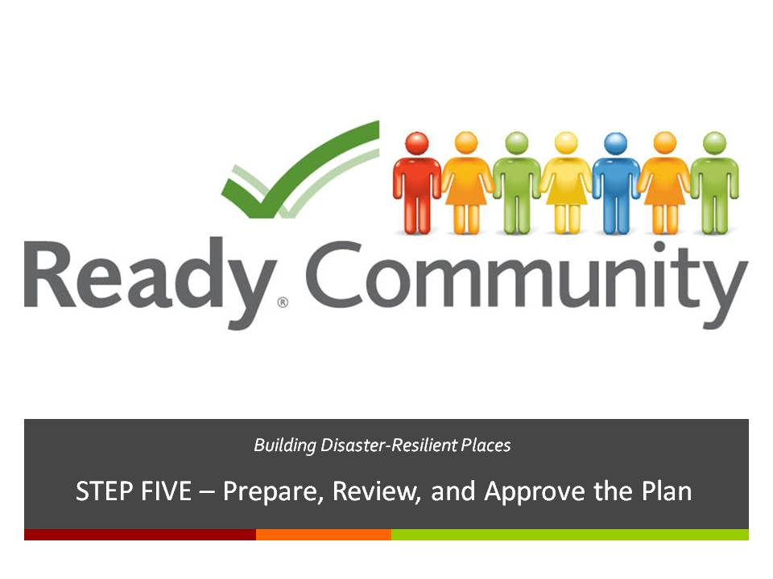  Supplies/Materials  Handout – PowerPoint Presentation (optional)  Estimated Time  5-10 min. (depending on size of the group)
Slide 2  A Review of What is Involved  As discussed in Step Four, the ReadyCommunity process follows six basic steps as outlined in CPG 101 and shown here.  Today we are beginning our work on Step Five – Prepare, Review, and Approve the Plan. | 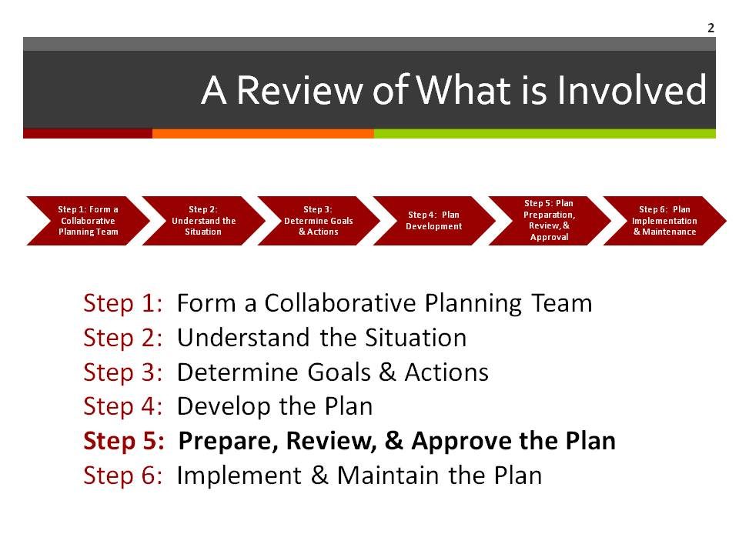  Supplies/Materials  Estimated Time  1 min.

STEP FIVE Prepare, Review, and Approve the Plan

Slide 3  Overview  The purpose of Step Five is to move the planning team toward the completion of the planning process itself.  These are the tasks for developing the plan:  - Refine the plan based on group feedback  - Complete the written plan  - Evaluate the plan to fit county/state guidelines  - Submit the plan to appropriate elected officials for approval  - Share the plan with the public, especially with vulnerable populations in the community | 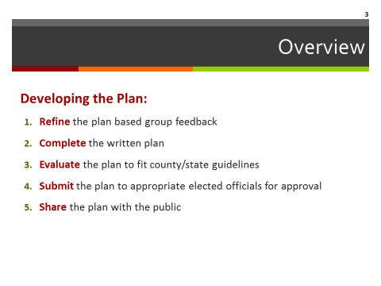  Supplies/Materials  Estimated Time  1 min.
STEP FIVE Prepare, Review, and Approve the Plan

Slide 4  Assembling the Pieces  Through this process you have completed several key components for an Emergency Operations Plan.  The Emergency Support Function worksheets you completed in Steps Three and Four will provide details of your plan along with the Action Plans from Step Four. | 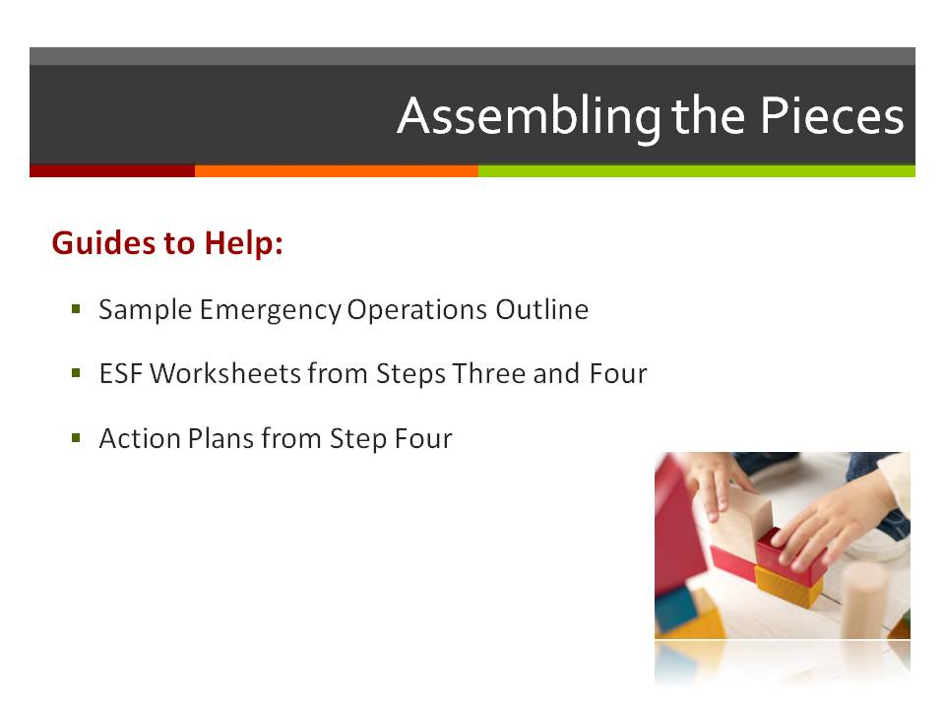  Supplies/Materials  ESF Worksheets from Steps Three and Four  Action Plans from Step Four  Estimated Time  5 min.

STEP FIVE Prepare, Review, and Approve the Plan

Slide 5  Overarching Plan  Allow time for the team that was drafting the content of the overarching Emergency Operation plan to present an overview. | 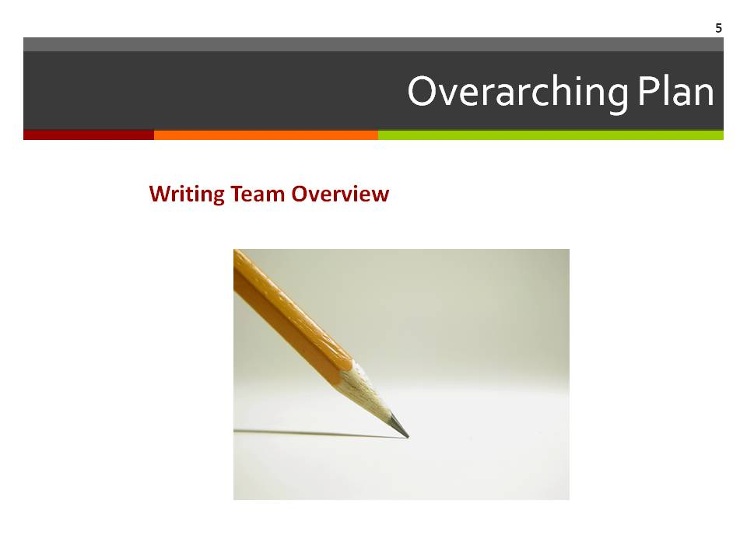  Supplies/Materials  Optional: copies of draft from team  Estimated Time  *15 min  Time may vary depending on how much discussion is needed

STEP FIVE Prepare, Review, and Approve the Plan

Slide 6  Big Picture Ideas  As the team prepares to get the final plan in writing, this slide provides some “big picture” guidance on what the final plan should accomplish.  The Plan should:  - Provide enough detail so people can act but not so much as to confuse what is expected  - Be organized so it is easy to find information quickly  - Provide general guidance, especially where unique or unexpected conditions can require adaptive responses  - Be accessible in multiple formats (full version, abridged version that can be easily transported by key personnel, public version [will be discussed more fully later in this session]) | 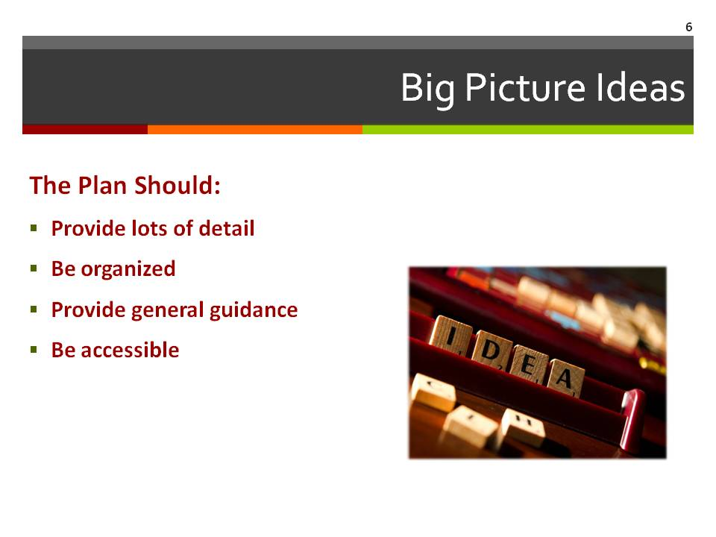  Supplies/Materials  Handout 1 - Evaluating the Plan  Estimated Time  2 min.
Use Handout 1: Evaluating the Plan to think through different aspects of the plan.

STEP FIVE Prepare, Review, and Approve the Plan

Slide 7  Testing the Plan  At this point, it would be helpful to use a scenario to conduct a final evaluation of the plan’s adequacy for preparing the community to respond to an emergency situation.  Test our plan by walking through a situation we might face to see what might happen.  Note to facilitator: You may want to change the graphics on this slide to represent your scenario.  It would be best to use a scenario that the planning group has developed to illustrate an emergency or disaster situation that has affected the community in the past.  If the group has not developed a scenario that reflects an emergency situation that has been or could be encountered, use the scenario provided by distributing Handout 2 – Scenario: Ice Storm. | 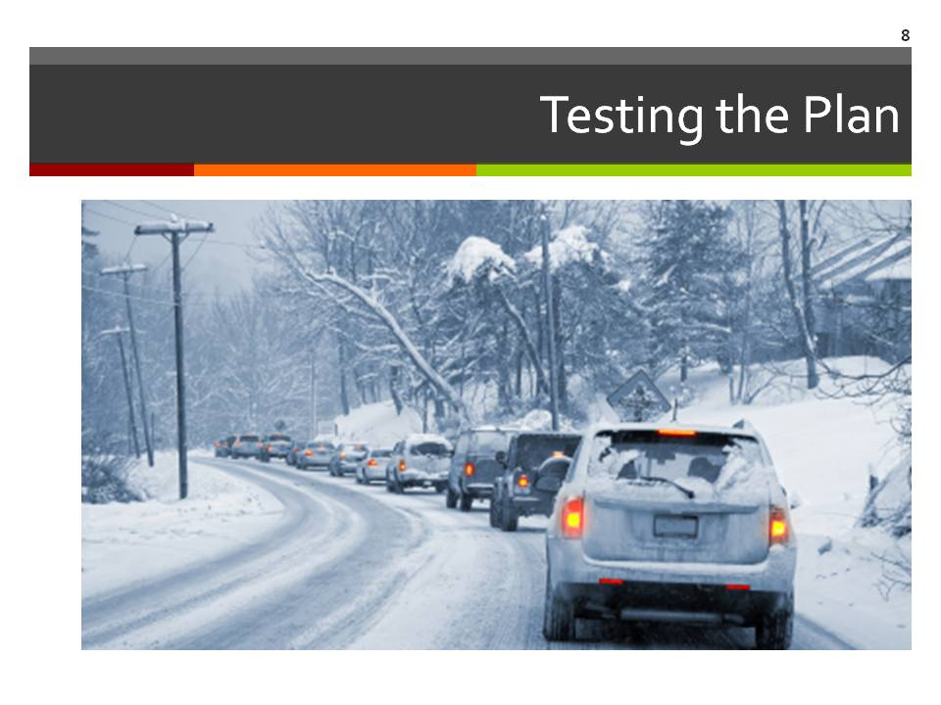  Supplies/Materials  Handout 2– Scenario: Ice Storm  (Use only if the planning team has not created or identified one of its own scenarios)  Estimated Time  75 min.

STEP FIVE Prepare, Review, and Approve the Plan

Slide 8  Plan Assessment  It is important to evaluate the plan this scenario.  A more complete list of questions to evaluate the community’s plan is included on pages 4-18 – 4-25 of CPG 101.  Distribute Handout 3 or 4, depending on the scenario you chose (see note to the right).  Using the handout and this slide, walk through each question and allow the planning team to answer and discuss each one.  Use these questions to evaluate the plan's performance in a scenario situation:  - Did an action, process, decision, or the timing make the situation better or worse?  - What parts of the action, process, decision, or timing make it something that:  - Must remain in the plan because of its effectiveness?  - Should be removed from the plan or altered because it was ineffective?  - Did the scenario identify any new courses of action?  - Did the plan ensure that the community’s special needs population received the kinds of assistance that would aid their safety and health? | 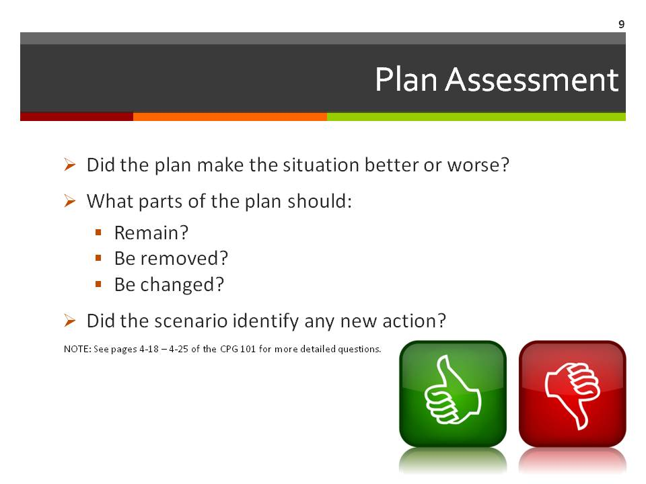  Supplies/Materials  Handout 1 – Evaluation Worksheet  Handout 2 – Ice Strom Evaluation Worksheet  (Use Handout 3 – Evaluation Worksheet if the planning team used their own scenario OR use Handout 4 – Ice Storm Evaluation if they used the ice storm scenario.)  Estimated Time  20 min.

STEP FIVE Prepare, Review, and Approve the Plan

Slide 9  Approval and Distribution of the Plan  Approval  Once the plan has been revised based on its evaluation, it is time for local officials to approve and adopt it, which should:  - Occur using a formal process based on state/county statute, law, or ordinance.  - Establish the authority for the plan.  Distribution  The plan should be distributed throughout the community to key persons and organizations that need access to information they need to guide their actions. | 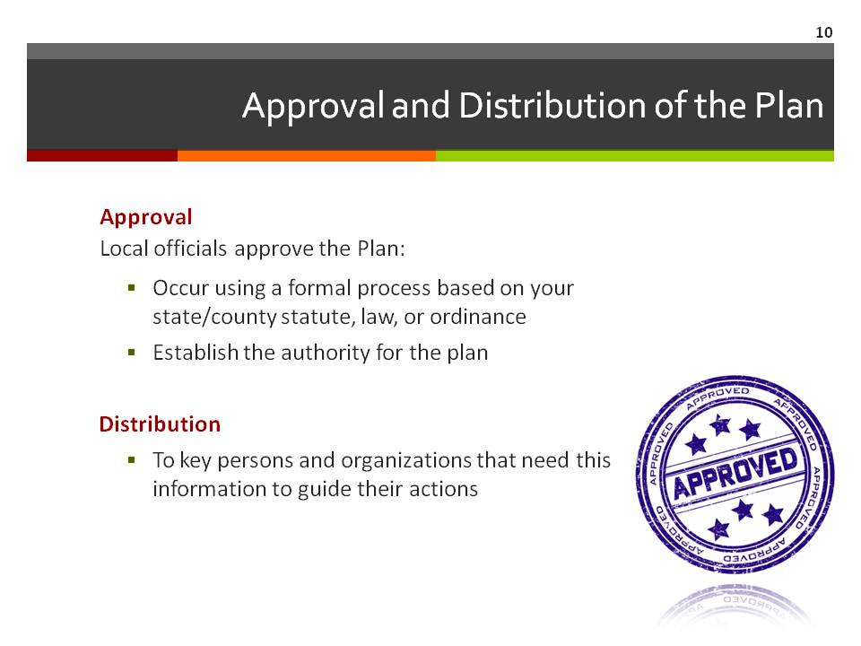  Supplies/Materials  Estimated Time  10 min.

STEP FIVE Prepare, Review, and Approve the Plan

Slide 10  Community Education and Preparation  There are stories of communities where a church has been identified in the plan as a shelter but no one at the church knew this or, the church did not have the capacity to shelter the number of people intended.  An Emergency Operations Plan is of little value if few in the community know of its existence or what it says. Thus, it is critical to develop an aggressive community education process.  To accomplish this, you first need to develop a “public” version of the plan. This is a version that removes all sensitive material from the plan.  Then develop a set of talking points that explain the key things everyone should know. Some examples include:  - Why do we need to be a ReadyCommunity?  - What are the biggest risks we face?  - What is going to happen in our community in an emergency?  - What should individuals do to prepare?  - What can individuals do to help the community respond to an emergency?  Handout 5 is a template that can help the planning team quickly develop a useable document. | 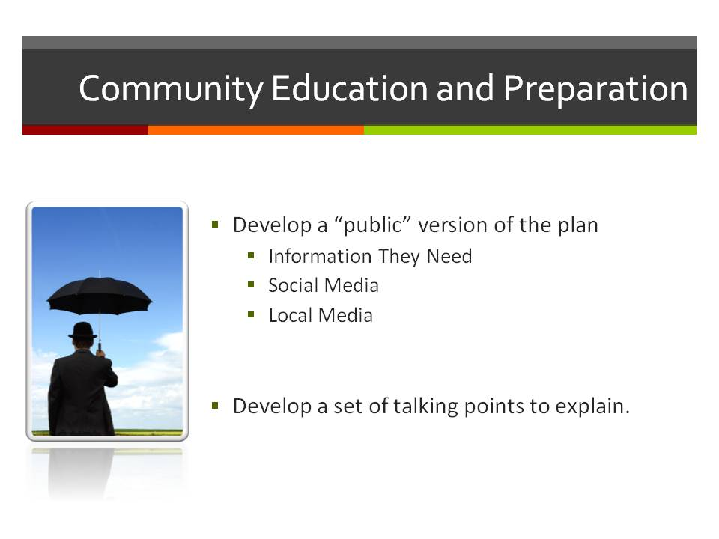  Supplies/Materials  Handout 5 – ReadyCommunity Brochure Template  Estimated Time  15 min.
Note to the facilitator: Secure commitment from an individual or team to draft a public document for use at the next session. The Ready Community Brochure Template is provided as one optional tool, but the team may choose another format
STEP FIVE Prepare, Review, and Approve the Plan

Slide 12  Looking Ahead: Sustaining the Plan  To be successful, you must avoid the “Mikey syndrome” which is completing the plan and then saying, “OK Director of Emergency Operations, this is now YOUR responsibility.”  It is not just Mikey’s responsibility. Becoming and staying a ReadyCommunity is everyone’s responsibility.  When an emergency occurs, our lives, our welfare, and our property will depend on whether we as a community have acted to insure that that the Emergency Operations Plan is a living document.  Be sure to ask participants:  - Where can we share information?  - What ways do people in this community get information?  In Step Six, we will discuss further how to sustain the community’s commitment to being a ReadyCommunity.  Sample debrief questions  - What are the most important communication avenues we have readily available and are already using  - What others could or should we consider incorporating? What would need to happen to make this a reality?  - Does our entire communication plan reach the whole spectrum of community? Go back to the list of hard to reach audiences (Step One). Does the communication plan address these concerns? | Supplies/Materials  Estimated Time  5 min.
STEP FIVE Prepare, Review, and Approve the Plan

Slide 13  Questions and Discussion  Review any items that the group needs to consider in preparation for the next step: Implement and Maintain the Plan.  The slide provides some structure to this discussion, but feel free to add other items that are relevant to the group.  List “To do” items on the flip chart and ask for volunteer(s) to complete each one by the next meeting. | 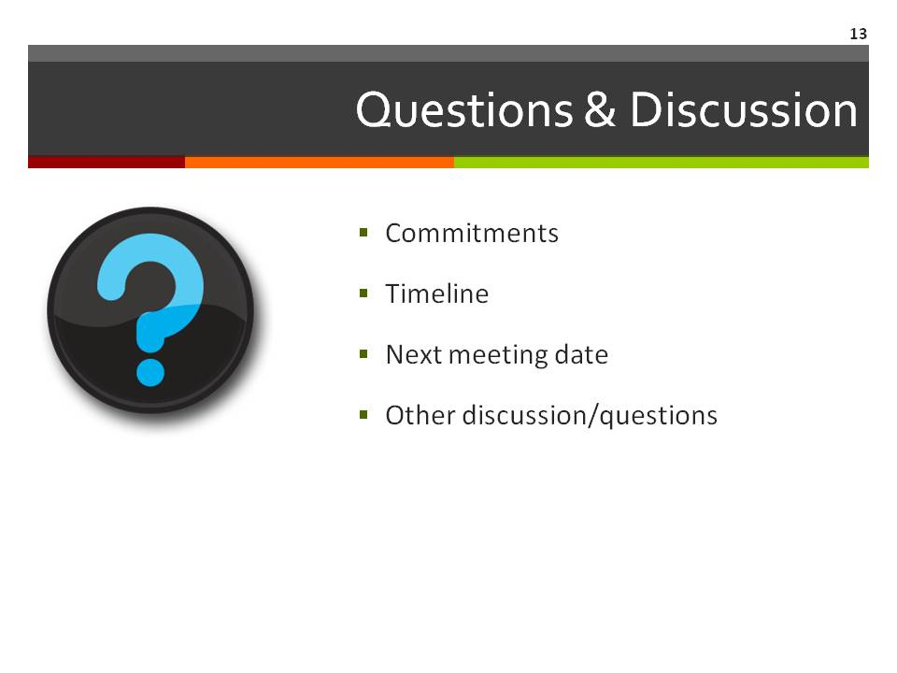  Supplies/Materials  Estimated Time  5 min.

Slide 14  Contact Information  Thank the team for their great work today.  Be sure to include your contact information as well as the local point person’s contact information so that all participants can stay connected to the planning process. | 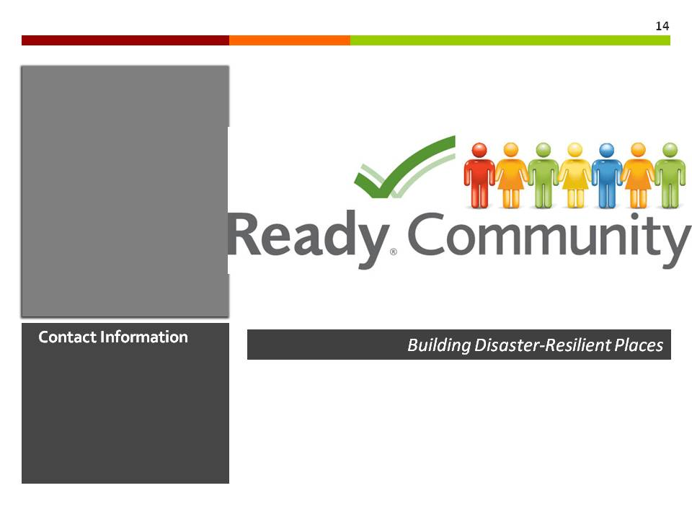  Supplies/Materials  Estimated Time  1 min.

