STEP FOUR

Develop the Plan

By Bo Beaulieu

Purdue Regional Development Center

Purdue University

Lori Garkovich

Community and Leadership Development

University of Kentucky

Rachel Welborn

Southern Rural Development Center

Mississippi State University

This facilitator’s guide outlines the content, activities, and handouts that should be used to teach this section. Refer to this document for detailed guidance on how to deliver ReadyCommunity Step Four.

STEP FOUR

Develop the Plan

Before Starting Step Four…
Prior to moving on to Step Four, the core and planning teams should complete these activities from Step Three:
- Refine Goals and Actions (using Handouts 2 and 3)

Step Four Overview
The fourth step of the ReadyCommunity training resources is intended to build on the information generated in Step Three. In particular, it seeks to generate the steps and necessary resources that will place the community on the path of achieving the goals and actions that the group finalized in Step Three.

Objectives
In Step Four, participants will:
- Review refined goals and actions/strategies from the previous session
- Identify specific steps needed to carry out the actions and to meet the key goals
- Identify resources available or needed to carry out the actions and steps

Estimated Time to Complete Step Four Activities
Two and a half hours plus additional time to complete the worksheets and homework in preparation for Step Five.

References to CPG 101
Pages 4-12 thru 4-16

Develop the Plan

In Step Four your local planning team will take the goals and actions from Step Three and develop a series of steps that it proposes to carry out to achieve each of the actions.

The team will then identify resources needed to accomplish the tasks at hand. They will explore how to identify local resources as well as secure connections to resources that are not available locally, if needed.

The team will organize all of the steps into a planning chart that will become part of the final plan.

Finally, the team will plan the Community Touch-Point associated with this step.

Advance Preparation

Two Weeks Prior
- Follow up with local point person
  - Confirm final count
  - Discuss any questions/concerns that may have surfaced
- Send out email reminder
  - Confirm date, time, location
  - Go over what they should expect, their responsibilities – Remind them that refined goals and actions are due at the upcoming meeting.
- Confirm food and beverages, if being provided, with local point person
- Double check logistical arrangements
- Print handouts (See “Supplies Needed” below)
- Add your contact information to the final slide of the “ReadyCommunity – Step Four” PowerPoint

Day of Event
Arrive at meeting place at least 45 minutes prior to meeting in order to:
- Set up PowerPoint equipment. Have the first slide displayed as participants arrive
- Arrange tables and chairs so that participants can be face-to-face. A U-shape works well with the projector screen in the opening of the U.
- Prepare a sign-in table so that you can ensure you have accurate contact information for all participants.
- Set up refreshments (optional).

Supplies Needed

Handout 1 – Emergency Plan Worksheet
Handout 2 – Emergency Plan Worksheet Example
Handout 3 – Sample Emergency Operations Plan
Computer
Projector
Screen or blank wall
Extension cord
Flip chart & easel
Sticky notes
Markers
Sign-in sheet
Nametags and name tents (unless all participants are well acquainted)
Calendar
Map of county/community

Support Documents
Comprehensive Planning Guide (CPG 101)

References
FEMA, 2003. Developing the Mitigation Plan: Identifying Mitigation Actions and Implementation Strategies. State and Local Mitigation Planning How-to Guide. FEMA 366-3 (April).

FEMA, 2010. Developing and Maintaining Emergency Operations Plans. Comprehensive Preparedness Guide (CPG) 101. Version 2.0 (2010).

STEP FOUR Develop the Plan

Slide 1  ReadyCommunity  Display the Welcome Slide so participants see it when they enter the room.  Welcome participants and allow time for introductions if participants are not already acquainted.  Warm up:  Ask each NEW person to share the following information:  - Name (If they are not already acquainted)  - Everyone: One thing or skill you hope you have if a disaster hits(tell them to name something in one or two words – fast)  Introduce today’s session.  During this session, participants will be developing the details of the community’s disaster plan. | 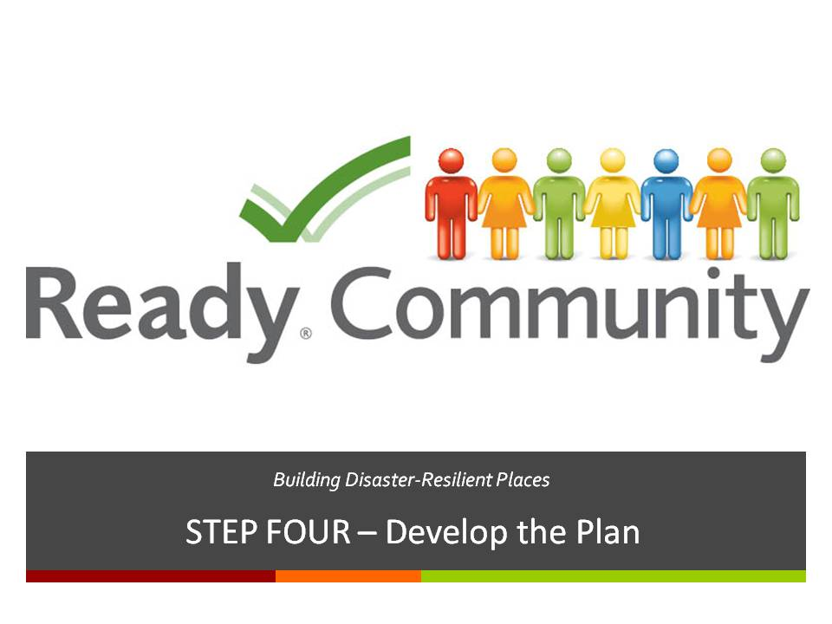  Supplies/Materials  Handout – PowerPoint Presentation (optional)  Flip Chart  Easel  Markers  Estimated Time  5-10 min. (depending on size of the group)
STEP FOUR Develop the Plan

Slide 2  A Review of What is Involved  Most of you have seen this slide before. As you know, we have now completed three of the six steps in the ReadyCommunity process. Today, we will work on the fourth step, Develop the Plan.  Step Four builds on the goals and actions identified in Step Three, setting the stage for the completion of the final plan in Step Five. | 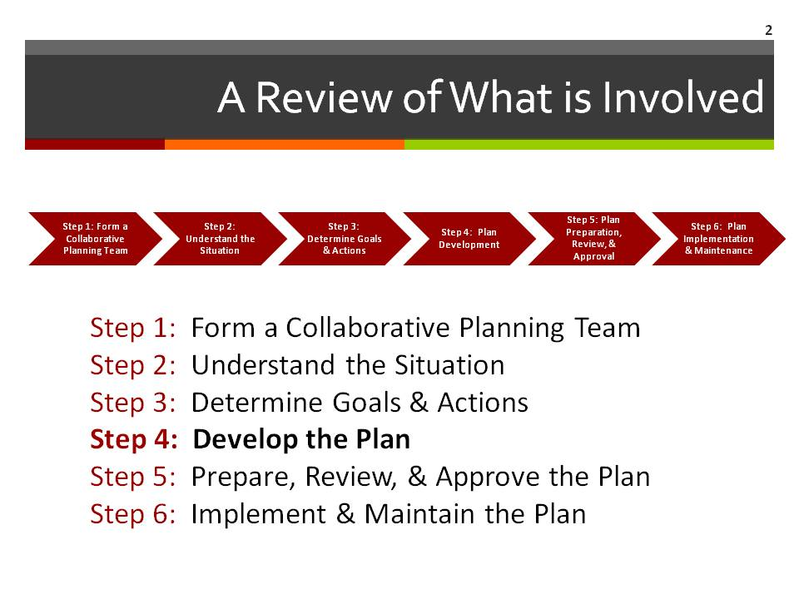  Supplies/Materials  Estimated Time  1 min.

STEP FOUR Develop the Plan

Slide 3  Overview  We will address three major topics in this session:  - Review refined goals and actions/strategies from the previous session  - Identify specific steps needed to carry out the actions and to meet the key goals  - Identify resources available or needed to carry out the actions and steps  - Examine a typical outline for the Emergency Operations Plan | 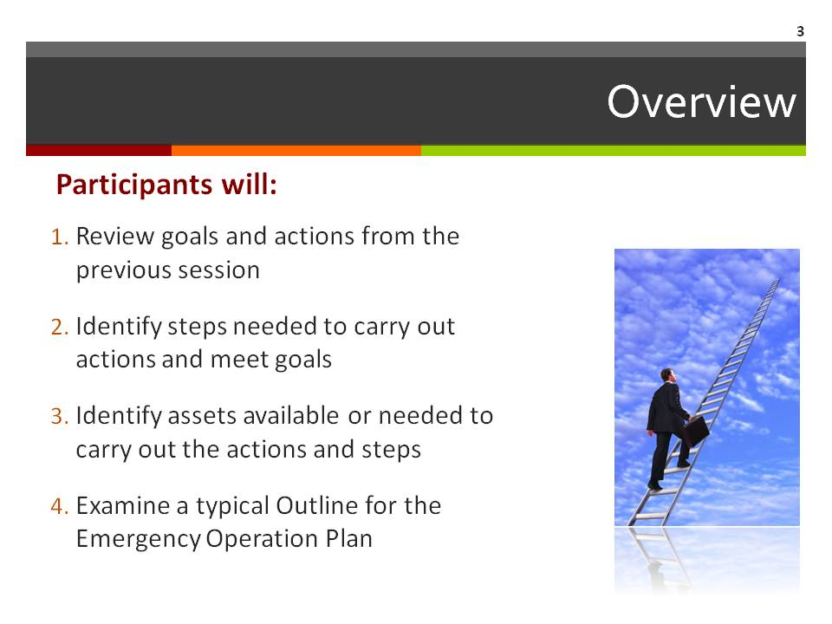  Supplies/Materials  Estimated Time  2 min.

STEP FOUR Develop the Plan

Slide 4  Review Goals & Actions from Step Three  As homework from Step Three, each team working on an ESF was to refine the goals and actions that were selected. Ask each team to quickly go over their final revisions and invite comments and suggestions.  Note to facilitator: Please be sure the group has enough time to provide additional feedback or to seek clarification on items presented by the ESF working teams. Step Four depends heavily on having the Step Three tasks completed and in good shape. So if needed, give the group time to fine-tune all of the pertinent ESF goals and actions/strategies. | 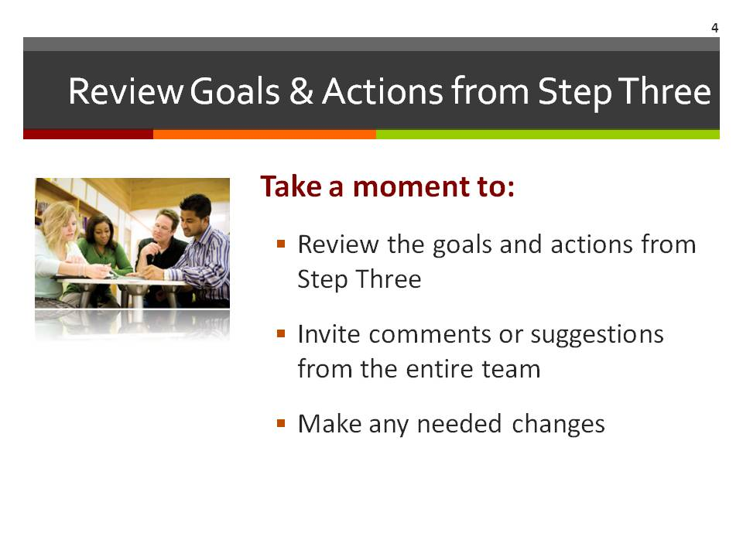  Supplies/Materials  Estimated Time  15 min.

STEP FOUR Develop the Plan

Slide 5  Putting “Legs” on Your Plan  We all recognize that launching specific actions does not happen magically. They need hands and feet to help get things moving in the right direction. Over the next few minutes, planning team members will be asked to develop the detailed steps needed to start the actions/strategies from Step 3.  Note to facilitator: Ask the participants to think about the things you need to do to assure that within 4 hours, all persons in a flood will be notified of potential flooding  - Identify flood prone areas  - Identify volunteers in area  - Identify language/demographics of area  - Identify neighborhood emergency point person  - Train volunteers  - Divide neighborhood into volunteer responsibility  What is no one volunteers to work on an action step?  - Let people pause for 10 seconds to gather their ideas  - Then ask – “Who in this neighborhood has dealt with this particular issue?” and identify someone in your current group to make the first contact. | 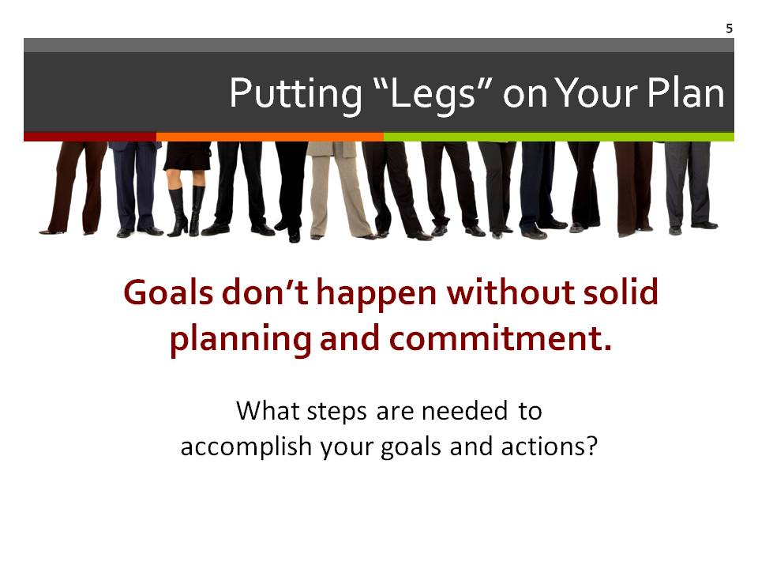  Supplies/Materials  Estimated Time  1 min.

STEP FOUR Develop the Plan

Slide 6  Steps to Get Started: An Example  This slide begins with a listing of the SMART Goal and the ACTION example from Step Three. Now the key question to be addressed is this: “How do we go about getting this work done?”  We provide an example of the STEPS that might make sense (organized in logical order) to reach this ACTION:  - Get a flood zone map.  - Divide the area into sections.  - Find people to be section leaders.  - Set leaders up on a call system.  - Teach leaders how to notify residents.  - Ask leaders to call back when finished.  As you can see, the STEPS are clear and achievable. | 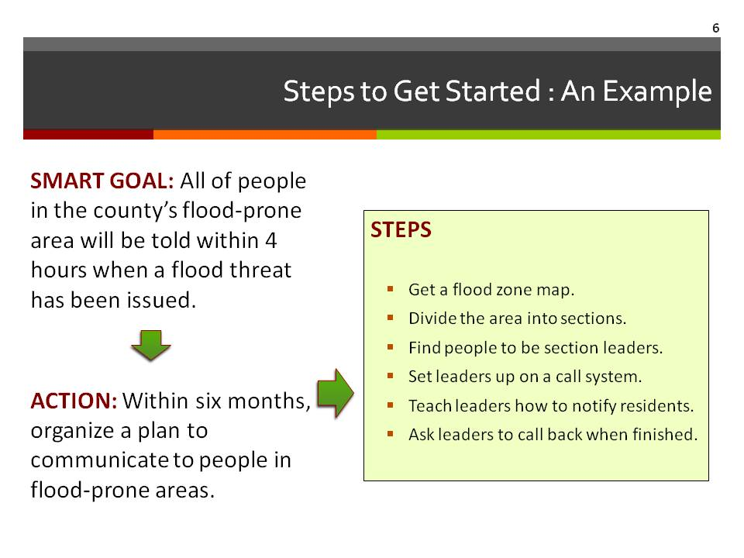  Supplies/Materials  Estimated Time  10 min.
STEP FOUR Develop the Plan

Slide 7  Your Plan: Moving Forward  As a planning committee, begin detailing the steps that could be taken for each action/strategy that the team chose in Step 3.  Here is one way to get this done:  - Start with one of the ESF-related SMART goals and its actions/strategies.  - Get the group to identify specific steps that should be pursued for each action/strategy.  - Next, organize the steps into a logical order. That is, think about what needs to happen first, then second, the third, and so on?  Facilitator Note: Make sure everyone understands the directions, then allow teams to work on the ESFs from Step Three. The group may find that working on large flip chart paper works best to rough out ideas and get them in order. Once the steps are in order, have them write them in the first column on Handout 1 – Emergency Plan Worksheet. We will talk about the other columns in coming slides. | 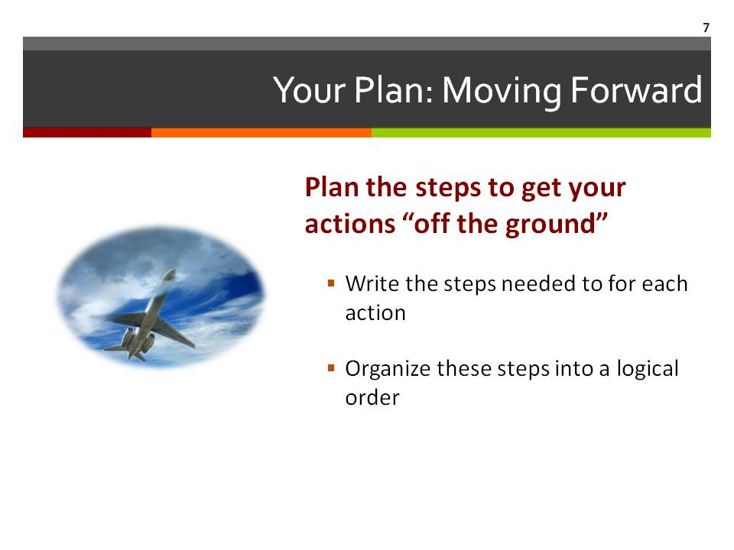  Supplies/Materials  Flip Chart  Markers  Handout 1 – Emergency Plan Worksheet  Handout 2 – Emergency Plan Worksheet Example (if needed)  Estimated Time  20 min.
STEP FOUR Develop the Plan

Slide 8  Finding What We Need  Now that the steps are planned for each action, we need to find out what things are needed to carry out each of these steps. The planning committee should think about FOUR major categories of resources:  - People who have specific knowledge, skills and experiences that relate to specific action steps the planning team has identified;  - Formal Organizations, such as local businesses, banks, schools, local governments, and churches, that have important resources that might be available to lend a helping hand;  - Volunteer Groups, such as civic and fraternal organizations, interested in helping with specific action steps;  - Physical Resources (Things) that are needed for certain steps, such as tractors, buses, commercial kitchens, shelters, and so on.  Starting on flipchart paper divided into four sections (see diagram), have each group list the resources they will need to accomplish their goals.  During the report back time, be sure to look for:  - Overlaps in resource use. For instance, are there two support teams (ESFs) that are planning to use the same resource at the same time? How will competing needs be addressed?  - Gaps in resources. Are teams overlooking resources that may be vital? Are access procedures clear so that the people that need to use specific resources can gain access to them quickly, without untimely delays? | 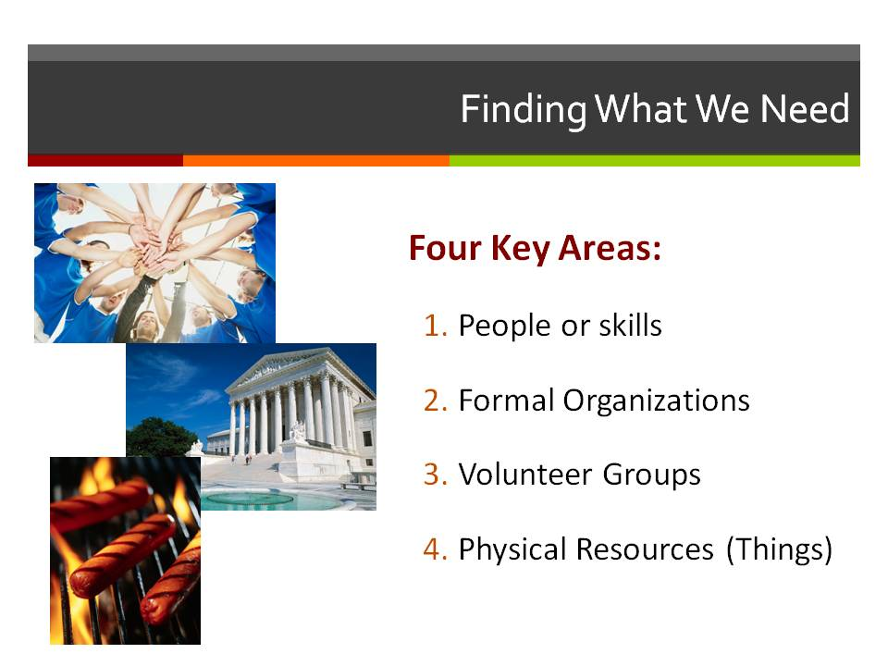  Supplies/Materials  Estimated Time  5 min.  Diagram:  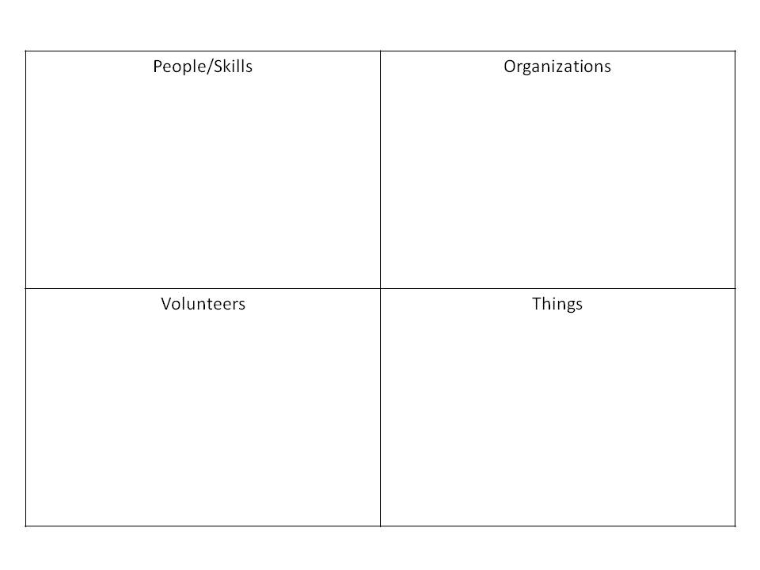
STEP FOUR Develop the Plan

Slide 9  At Your Fingertips  Another key question that must be considered when it comes to “resources” is how accessible are they during a disaster? That is, how can you be sure that you have local access to needed resources when a disaster strikes? Likewise, what procedures are in place to get outside help if the disaster is beyond the ability of the local community to tackle?  Planning committee members should think through the resources they need for each of the steps they have identified. What do they have locally? What do they need to do to gain outside support, if needed? Who is the contact for those resources, both inside and outside the community? Are Memorandums of Understanding (MOU) in place to speed outside assistance? [Note to facilitator: if people are not familiar with MOU’s, explain that they are formal agreements between organizations (or communities) to help each other. Typically those cover:  - Who is the contact for resources?  - What process will be used to get the resources?  Have groups place a green checkmark by the resources you have and red X by the ones they do not have. Talk about how you will get what you need? Is it available locally? You may be able to find out in the last community open house. Or do you need to work with a neighboring organization (city/county) to get help?  Talk about how you will get access to the things you do not have. Do you need to have an MOU? With whom? Who will take this responsibility? (Add this as an step on the Emergency Plan Worksheet if not already there.  Add resource information on the bottom of Handout 3 from Step 3. | 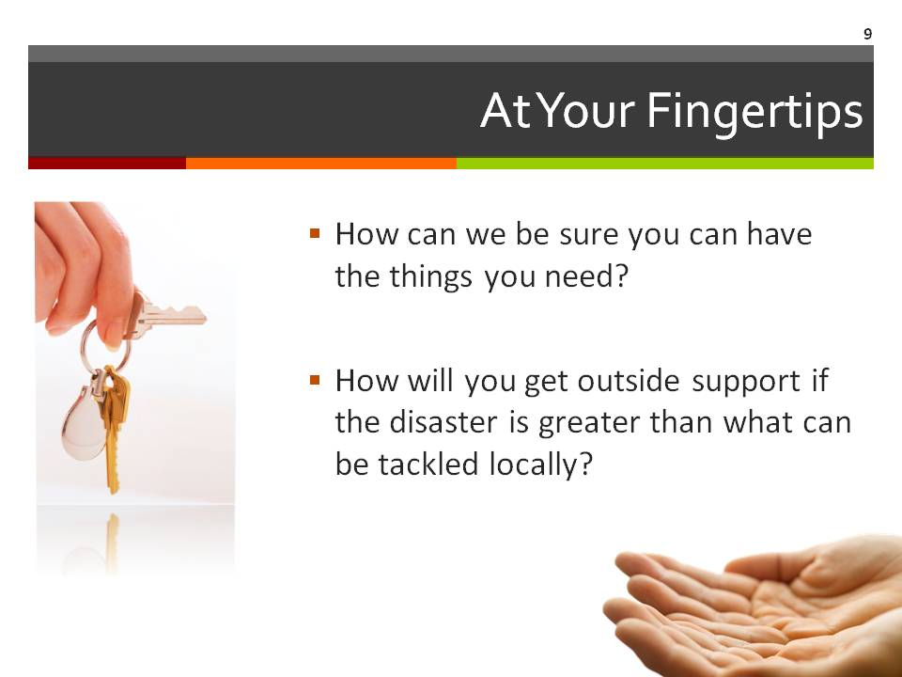  Supplies/Materials  Flip Chart  Markers  Estimated Time  20 min.
STEP FOUR Develop the Plan

Slide 10  Your Plan: Connections the Dots  The final step in this part of the process is putting all the pieces together.  The sticky note chart helps you to see your plan for each of the ESF-related SMART goals that you have developed.  For each action/strategy being proposed, specify the following:  - Specific Steps needed to carry out each action/strategy  - Person(s) responsible for each step  - Other partners that will be able to assist with each step (such as people, agencies and organizations)  - Other resources (physical resources) available to support the work associated with this step  - Timeline for completion of each step  Use Handout 1 - Emergency Plan Worksheet  Use Handout 2 – Emergency Plan Worksheet Example if you need direction | 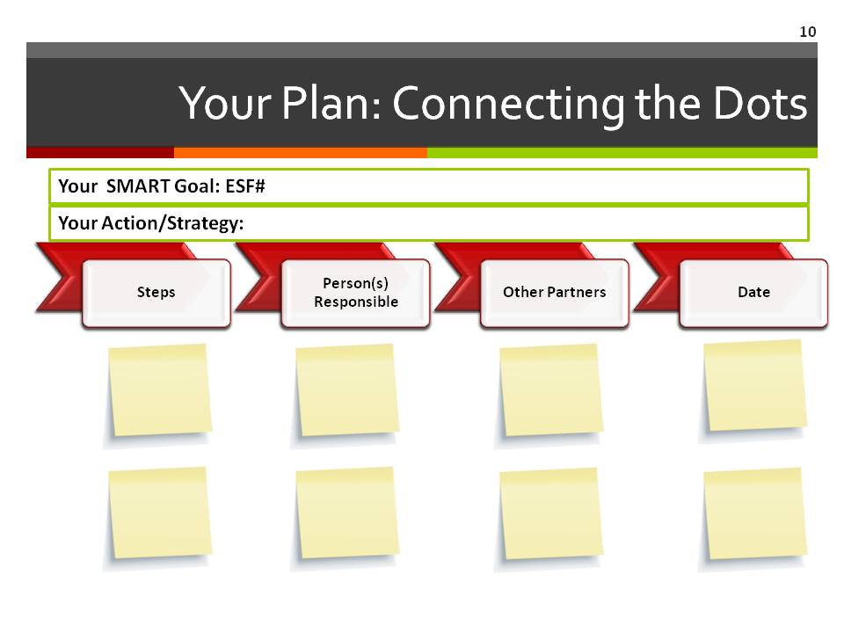  Supplies/Materials  Handout 1 – Emergency Plan Worksheet  Handout 2 – Emergency Plan Worksheet Example (if needed)  Estimated Time  20 min.

STEP FOUR Develop the Plan

Slide 11  Your Plan: Connections the Dots  Looking at the Big Picture  Thus for we have been considering a more detailed look at what needs to happen in case of a disaster.  Now we back up and look at the plan from a broader prospective. The Emergency Operation Plan requires some overarching information. [Hands out the sample emergency operation plan outline or the states required outline if available.]  Lead a discussion about the outline content.  - What questions need to be answered?  - Who can write the various sections? | Supplies/Materials  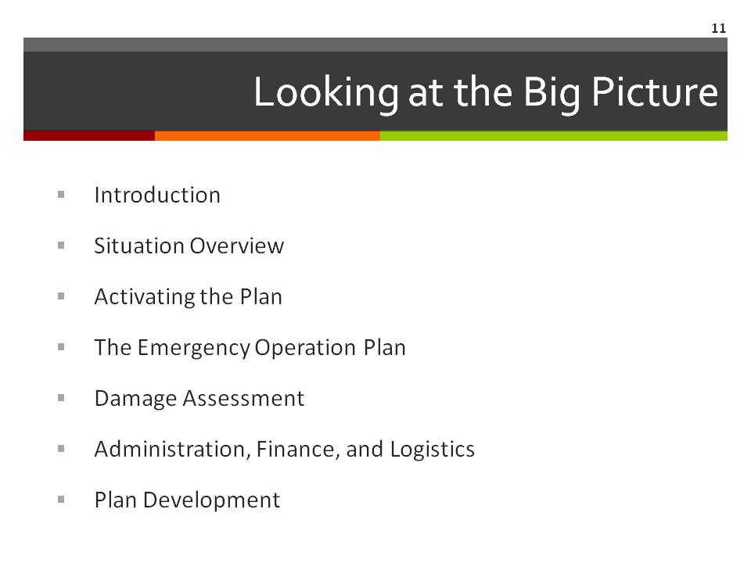  Handout 3 – Sample Emergency Operations Plan OR  State’s required outline/guidance  Estimated Time

STEP FOUR Develop the Plan

Slide 12  Questions & Next Steps  Take time to debrief today’s activities and clarify or revisit topics that may remain unclear to the planning team.  Next, remind the group of the activities that need to be completed prior to moving to Step Five. This includes making sure everyone knows their assigned responsibilities in terms of planning and hosting the Community Open House. | 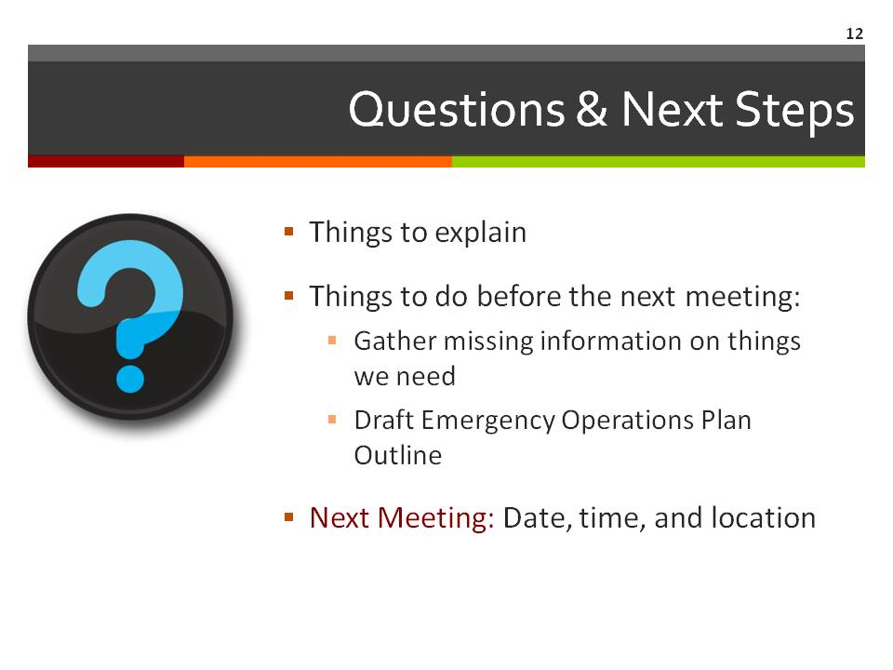  Supplies/Materials  Estimated Time  5 min.

Slide 13  Contact Information  Thank participants for coming.  Be sure to include your contact information as well as the local point person’s contact information so that all participants can stay connected to the planning process. | 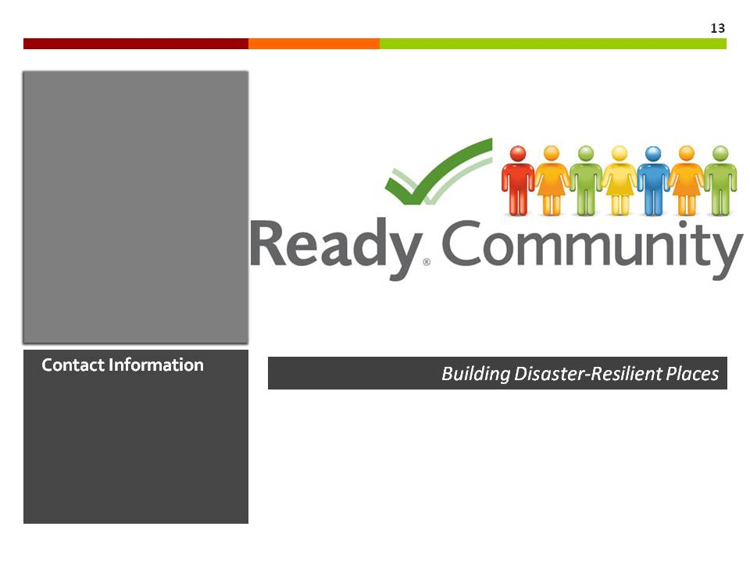  Supplies/Materials  Estimated Time  1 min.

