Data Sources
Gathering information about the make up of your community will ensure you are considering all populations in your community as you develop a plan, and that you are engaging them in the plan’s development. Below are websites to assist you with gathering the community’s demographic data.
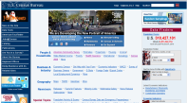
Census Bureau - Main Portal
http://www.census.gov/

US Census QuickFacts
http://quickfacts.census.gov

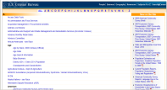
Census Bureau A-Z Subjects
http://www.census.gov/main/www/subjects.html

Census of Agriculture
http://www.nass.usda.gov/Census_of_Agriculture/index.asp

Southern Rural Development Center Community Data Center
http://srdc.msstate.edu/data/center/

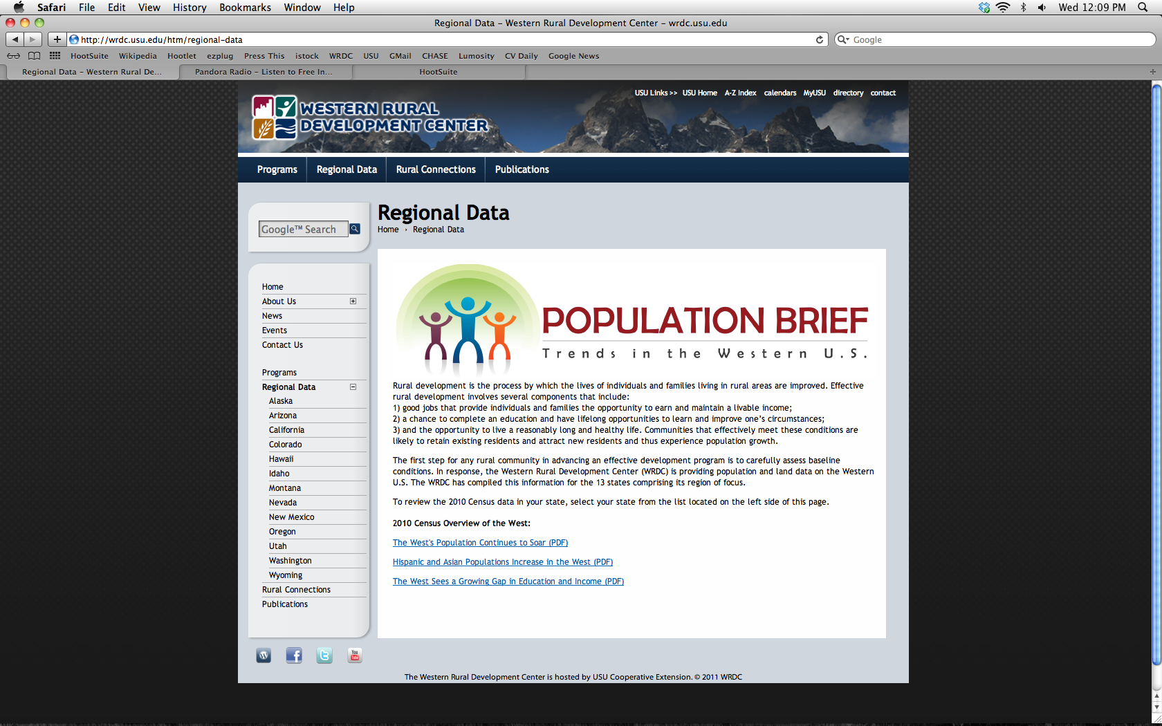
Western Rural Development Center Regional Data
http://wrdc.usu.edu/htm/regional-data

