Digital Skills Development Survey

Purpose of Evaluation:

Evaluation is a critical component for the program to estimate the impact of the resources. It allows us to answer the questions that focus on the value of the training. The evaluation feedback is important for the funders to receive to be accountable for the use of public resources. The summaries help to communicate the value of the public investment in the effort to not only the funders but also the program partners. The feedback is also valuable to individual educators aiding them in communicating the impact and/or value of their individual effort(s).

You may request your data, quarterly, from SRCD by reaching out to John, Rachel, or Roseanne.

Please draw participants’ attention to this statement at the top of each survey form. The one from the workshop survey is below and the 3-month survey is similar:

Please provide your feedback. The project involves research which includes completing a postworkshop survey and one after 3 months. Participation is voluntary, but your input is important. Individual responses will be confidential. Reports will be in summary form. Participant is under the age of 18 are not able to take part in the survey.

Evaluation Tools:
- Post-Workshop Survey to be used at the close of training.
- 3-Month Follow-up Survey – to be used after about three months. This can be done by electronic survey, paper survey, or by a follow-up visit or phone call.
- Presenter Post-Workshop Survey
- Site Representative Post-Workshop Survey
- QR codes and links can be used for any of the above surveys if participants prefer to respond online.

Process:
Immediately after a workshop:
- At the close of each training session, please administer the post-workshop survey. The top section should be completed by the facilitator/presenter prior to handing out to participant. For those completing an electronic version, you may need to coach them on what to put in these blanks as they may not recognize the name of the session presented.
- You may administer paper copies and/or invite participants to fill out the survey online. You have paper copy, URL links, and a QR code to the online survey in this packet.
- If you use paper copies, please enter the data to Qualtrics.

3 Month Follow-Up:
- Using your sign-in sheet from the workshop, send the three-month follow-up survey to participants, asking them to complete and mail back OR you can use the URL link or QR Code for the 3 month follow up and send to them electronically if you have email addresses. You can also offer this survey face-to-face if you are meeting with the participants for continued support.
- If you use paper copies, please enter the data to Qualtrics.

Presenter Survey:
- Immediately after workshop (if presenting a single workshop) or after completion of a series of workshops, all individuals teaching material complete survey.
- If you use paper copies, please enter the data to Qualtrics.

Site Survey:
- Immediately after workshop (if hosting a single workshop) or after completion of a series of workshops, a site staff member completes survey.
- If you use paper copies, please enter the data to Qualtrics.

Got questions? We’re here to help:

Rachel Welborn, Associate Director, Southern Rural Development Center
rachel.welborn@msstate.edu

John Green, Director, Southern Rural Development Center
john.green@msstate.edu

Roseanne Scammahorn, Research Extension Associate III, Southern Rural Development Center
r.scammahorn@msstate.edu

Southern Rural Development Center
P.O. Box 5187
MS State, MS 39762
662-325-0595

Links and QR Codes for Qualtrics survey instruments

Post-Workshop Survey: https://msudafvm.co1.qualtrics.com/jfe/form/SV_cXWgAGp17h2jc22

3 Month Follow-Up: https://msudafvm.co1.qualtrics.com/jfe/form/SV_5pbhB5MDjDqH86q
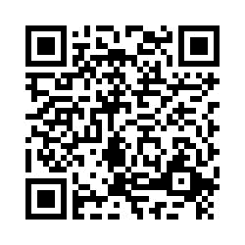

Presenter Survey: https://msudafvm.co1.qualtrics.com/jfe/form/SV_3sLT1BCky4EETOu
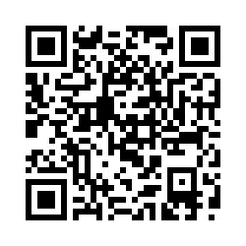

Site Survey: https://msudafvm.co1.qualtrics.com/jfe/form/SV_6fk9gTb2SbD4ij4
