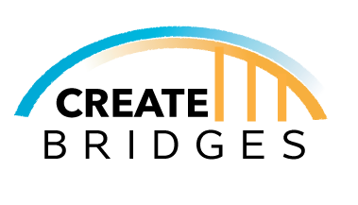

NEW MEXICO CREATE BRIDGES INTIATIVE (NM CBI)

PRIORITY, STRATEGY AND PLAN OF ACTION

WORKSHEETS

NEW MEXICO CREATE BRIDGES INTIATIVE (NM CBI)

PRIORITY, STRATEGY AND PLAN OF ACTION

WORKSHEET

Date:

NM CBI Regional Steering Committee Members
(Name and County)

1.

2.

3.

4.

5.

NM CBI PRIORITY (identify):

STRATEGY (describe):

NEED (describe and provide evidence- data, studies, reports, etc., of the need):

COUNTIES INVOLVED (identify NEEDO counties that will be participating in the strategy):

RESOURCE PARTNERS (names and roles of outside resource partners involved):

STRATEGY SPECIFICS:

What activities will be undertaken (provide details)

Where will the activities take place (identify the NM CBI counties and
communities that will be involved)

Who will be responsible for organizing and implementing the activities (names, roles, and responsibilities of regional steering committee members and others that will be involved)

When will the activities take place (beginning and ending dates)

How will the activities be paid-for (provide itemized budget and funding sources)

