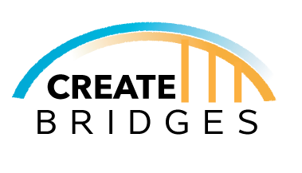
Evaluation for Strategy Meetings

- How did you hear about the Strategy Meeting?

- Why did you decide to participate in the Strategy Meeting?

- Please indicate the extent to which you agree or disagree with the following statements:
 | Disagree | Slightly Disagree | Neither Disagree Nor Agree | Slightly Agree | Agree
- The strategy session was a good use of my time. | 1 | 2 | 3 | 4 | 5
- The recap of data, themes, and opportunities for action laid the groundwork for this meeting.
- Strategies were developed based off the data presented in the CREATE Academy.
- Strategies to support CREATE businesses were developed in this meeting.
- Strategies to support the CREATE workforce were developed in this meeting.
- A Plan of Action was clearly established in this meeting. | 1 | 2 | 3 | 4 | 5

- What were the greatest strengths of this Strategy Meeting?

- What do you believe could have made this Strategy Meeting better?

- Do you have any other thoughts about the Strategy Meeting that you would like to share?

Demographics
- What county do you live in?

- Are you a member of the Regional Steering Committee?
- Yes
- No

- If not, have you participated in other CREATE BRIDGES activities?
- Yes
- No

- If yes, what activities?
- CREATE Forum
- Business Retention & Expansion (BRE) Survey
- Employee Perspectives Survey
- CREATE Academy
- Other
  - If Other, please specify _________

- Are you a business owner or manager in one of the CREATE sectors?
- Yes
- No

- Are you employed?
- Yes
- No

- What sector? (If Yes is selected)
- Education
- Retail
- Workforce
- Government
- Tourism
- Non-profit
- Other (please describe): ____________________________

- If not employed, are you seeking employment?
- Yes
- No

- What is your gender?
- Male
- Female
- Other/Prefer not to answer

- What is your race? Check all that apply
- White
- Black or African American
- American Indian or Alaska Native
- Asian
- Native Hawaiian or Pacific Islander
- Two or more races

- Are you Hispanic or Latino?
- Yes
- No

- Are you a person with a disability?
- Yes
- No

- Are you a veteran?
- Yes
- No

- What is your age group?
- 13-18
- 19-24
- 25-55
- 56+
- Prefer not to answer

Access the evaluation survey online:

