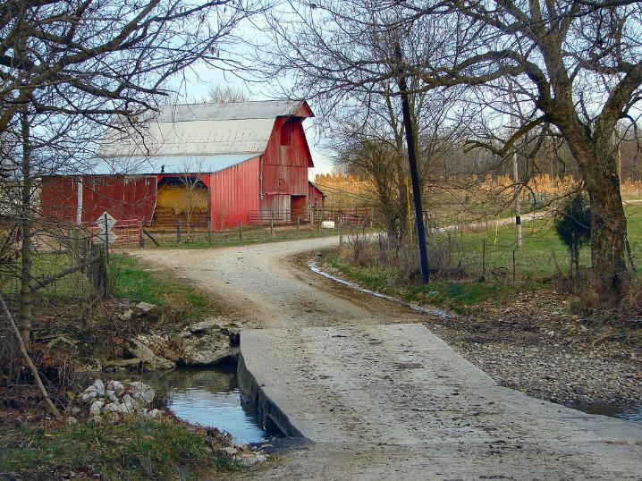
Understanding
Heirs’ Property
at the
Community Level

ABOUT THE TRAINING
Heirs’ property is a significant cause of land loss. To address this concern, a team of leading educators in the field have designed a three-part training to help community members take action to protect their lands. The three sections walk participants through an overview of heirs’ property, strategies for preventing heirs’ property, and key considerations in resolving heirs’ property. The National Policy Center at Alcorn State University, the Southern Risk Management Education Center (SRMEC), and the Southern Rural Development Center (SRDC) at Mississippi State University are anchor partners in the effort through funding from USDA National Institute of Food and Agriculture (NIFA), Farm Service Agency, and National Resource Conservation Service.

ADD YOUR LOGO(S) AND
INSTITUTIONAL EO STATEMENT HERE
For disability accommodation, please contact [Name]
at [phone number/email address]

CONTACT INFORMATION

Name

Email

Telephone number

DATE/TIME

Day of week, month day, year

Time with time zone

lOCATION

Building

Street address

City, state zip code

This Photo by Unknown Author is licensed under CC BY-NC

